

A PROJECT REPORT ON

**Build a flower classification model with Azure Custom Vision**

**Submitted By:**

Swapnali Gavali

2021-B-17082003B

**Group Member’s Names:**

Saniya Wagh

Anvesh Hirve

Lekha Ahirrao

Rohan Siddu Samudrala

**Presented to:**

Abhay Dhanmeher

(Program Trainee)

**Overview:**

The goal of this project is to build and deploy a custom image classification model that can accurately identify various types of flowers using Azure Custom Vision.

**Procedure:**

* **Clone Repository:**

Opened visual studio, Clone the repository to a local folder. [**https://github.com/sfoteini/azure-custom-vision.git**](https://github.com/sfoteini/azure-custom-vision.git)

* **Create a Custom Vision Resource:**
* Open Azure portal at <https://portal.azure.com>.Sign in to the [Azure Portal](https://portal.azure.com/) and select the create a resource button, and searched for custom vision, and created a custom vision resource.

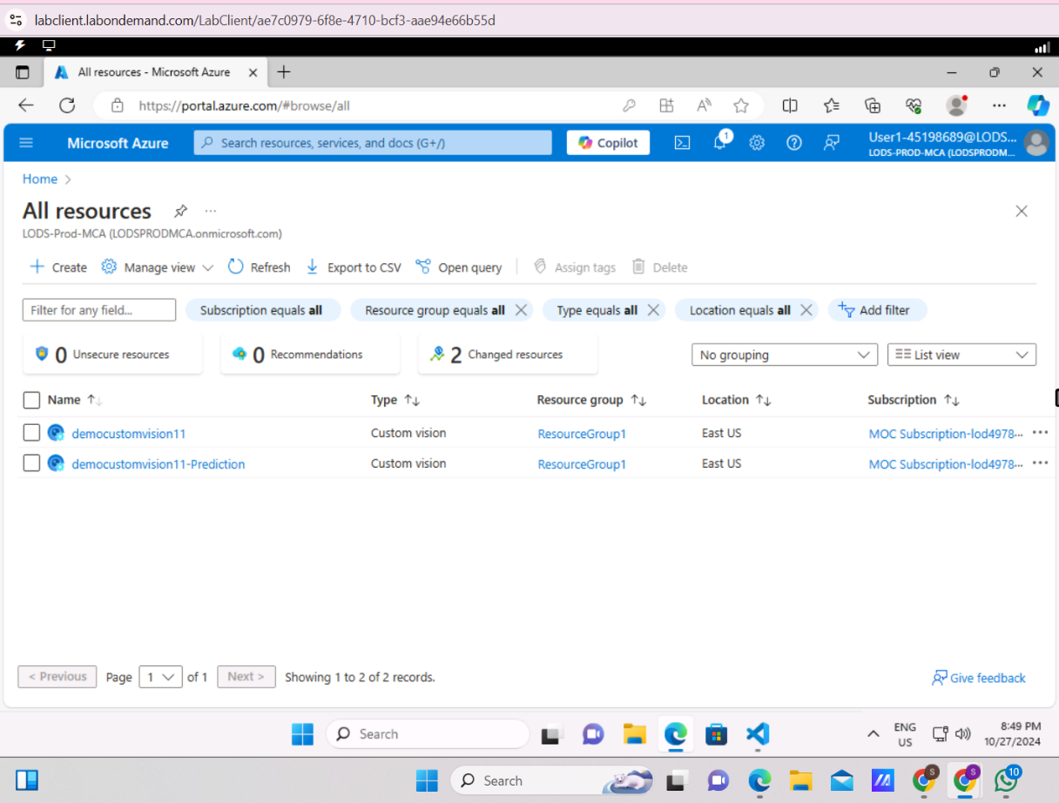

* **Create a new Custom Vision project:**

Navigate to the [Custom Vision portal](https://www.customvision.ai/) and sign in. Create a new project with the following settings:

* + **Name**: ClassifyFlowers
  + **Description**: Image classification for flowers.
  + **Resource**: democustomvision11
  + **Project Types**: Classification
  + **Classification Types**: Multiclass (single tag per image)
  + **Domains**: General.
* **Upload and tag images:**

In Custom Vision project, select Add images. Select all the images in the folder, Then upload the image files and specify the tag.

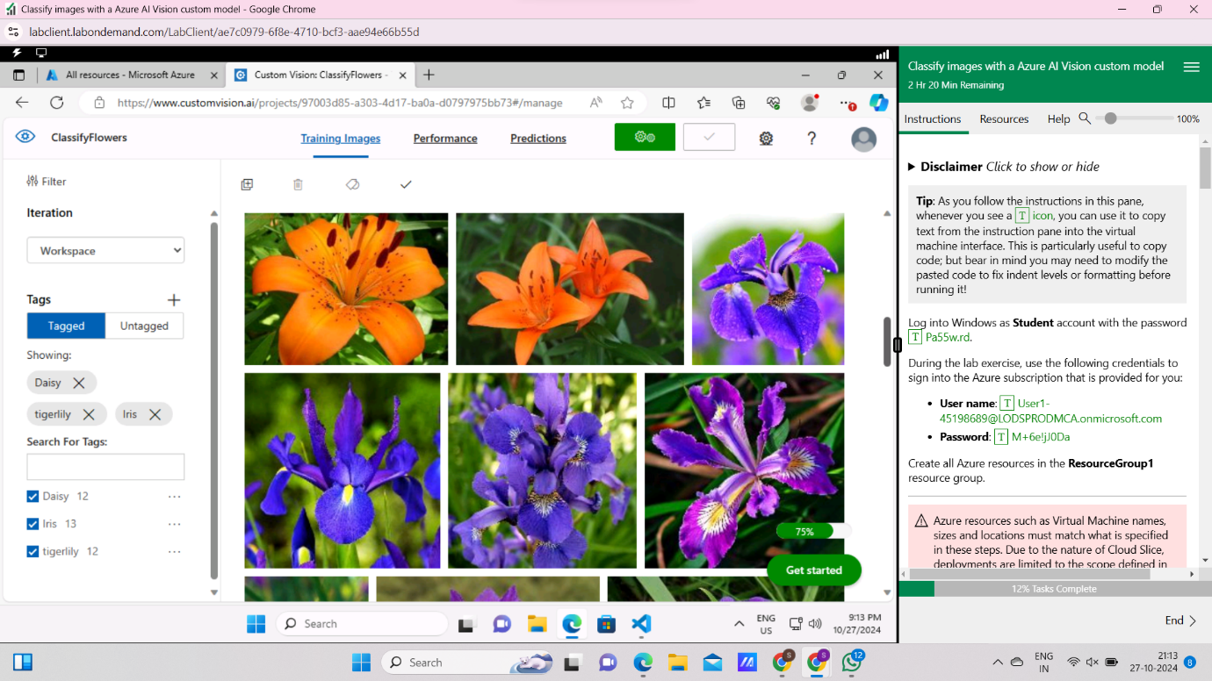

* **Train the model:**

In the top menu bar, click the **Train** button to train the model using the tagged images.Then, in the **Choose Training Type** window, select **Quick Training** and wait for the training iteration to complete.

* **Evaluate the classification model:**

When the training finishes, information about the model’s performance is estimated and displayed.

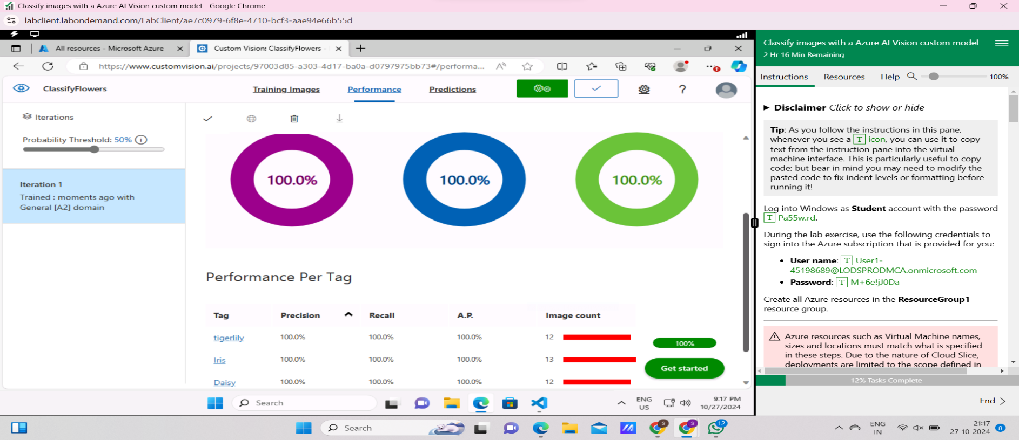

* **Test the model:**

In the top menu bar, select **Quick Test**.In the **Quick Test** window, click the **Browse local files** button and select a local image. The prediction is shown in the window.

* **Tested Model:**

Following are the output of the trained model.

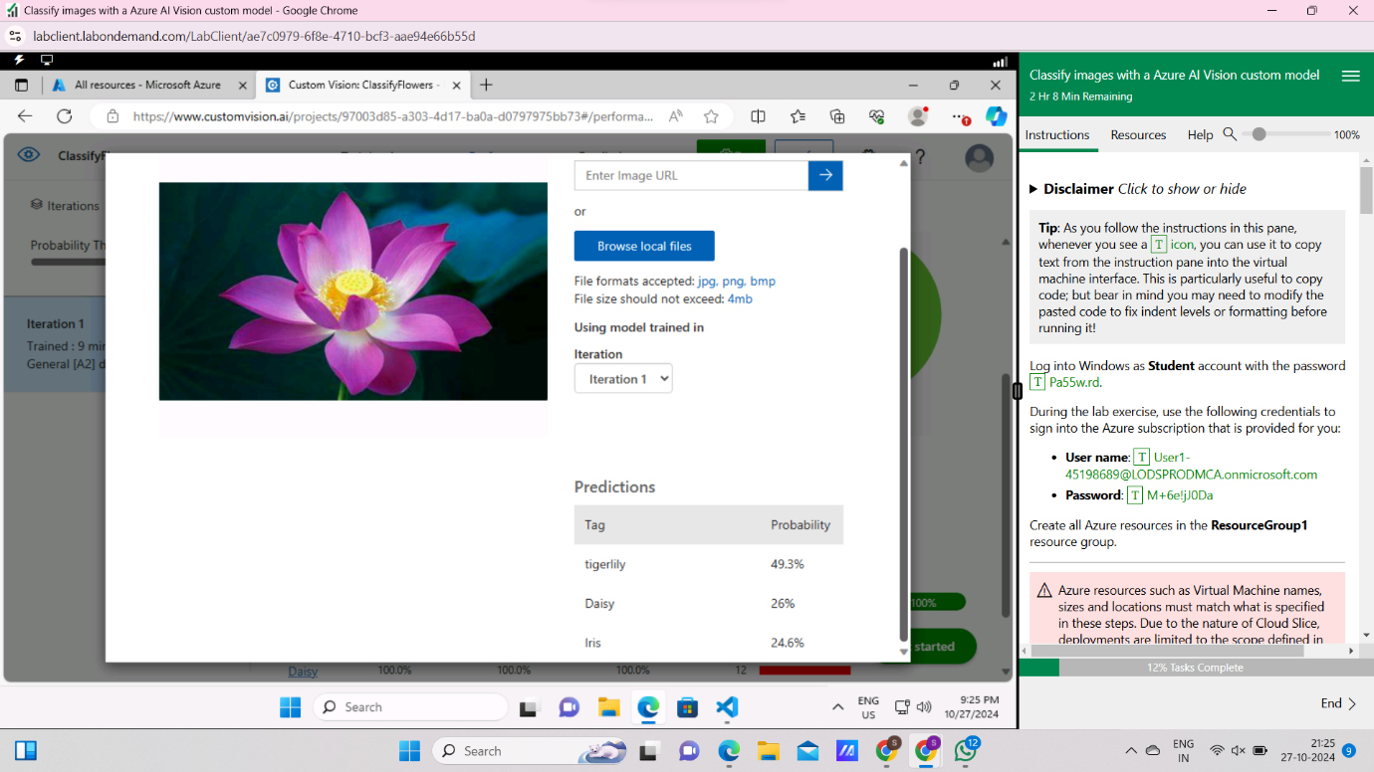

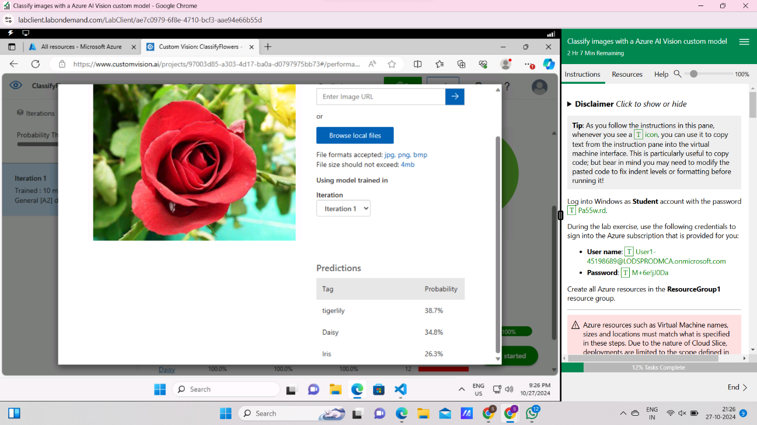

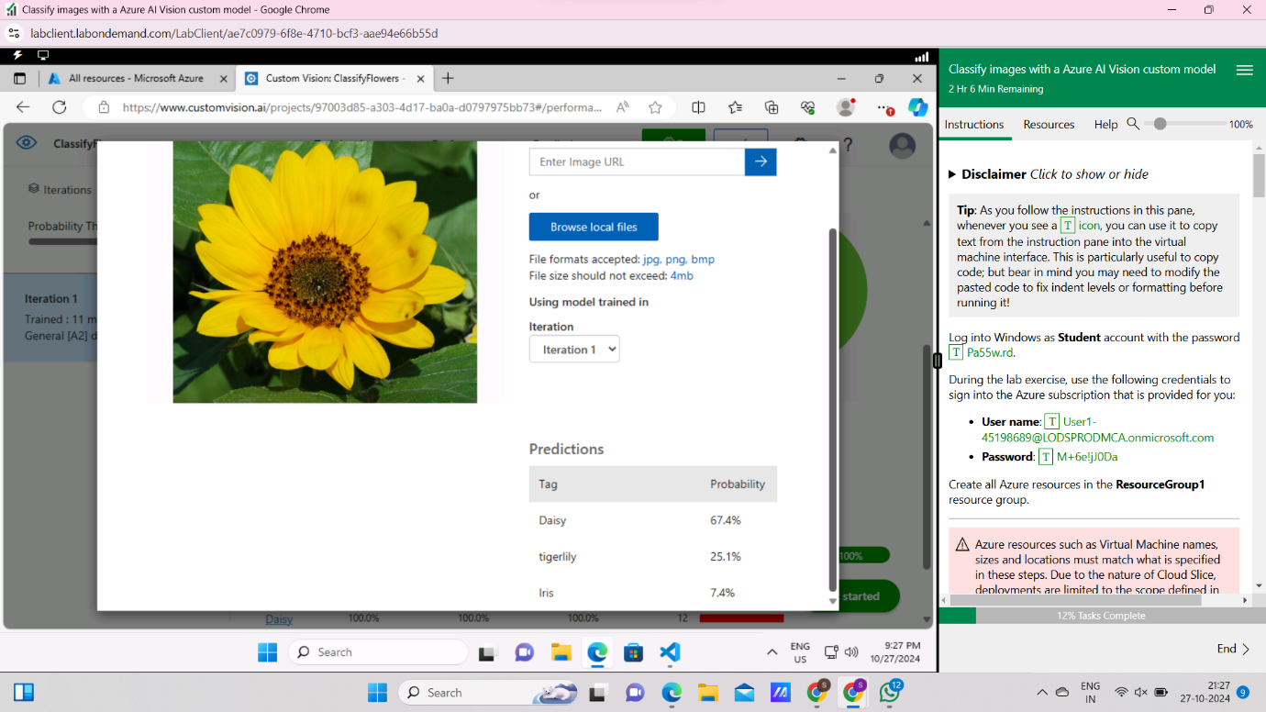

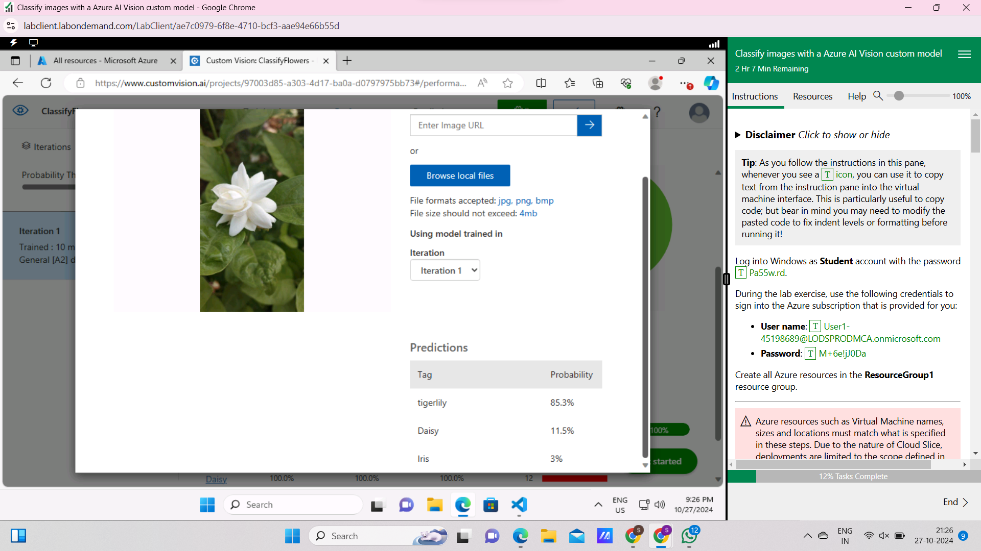

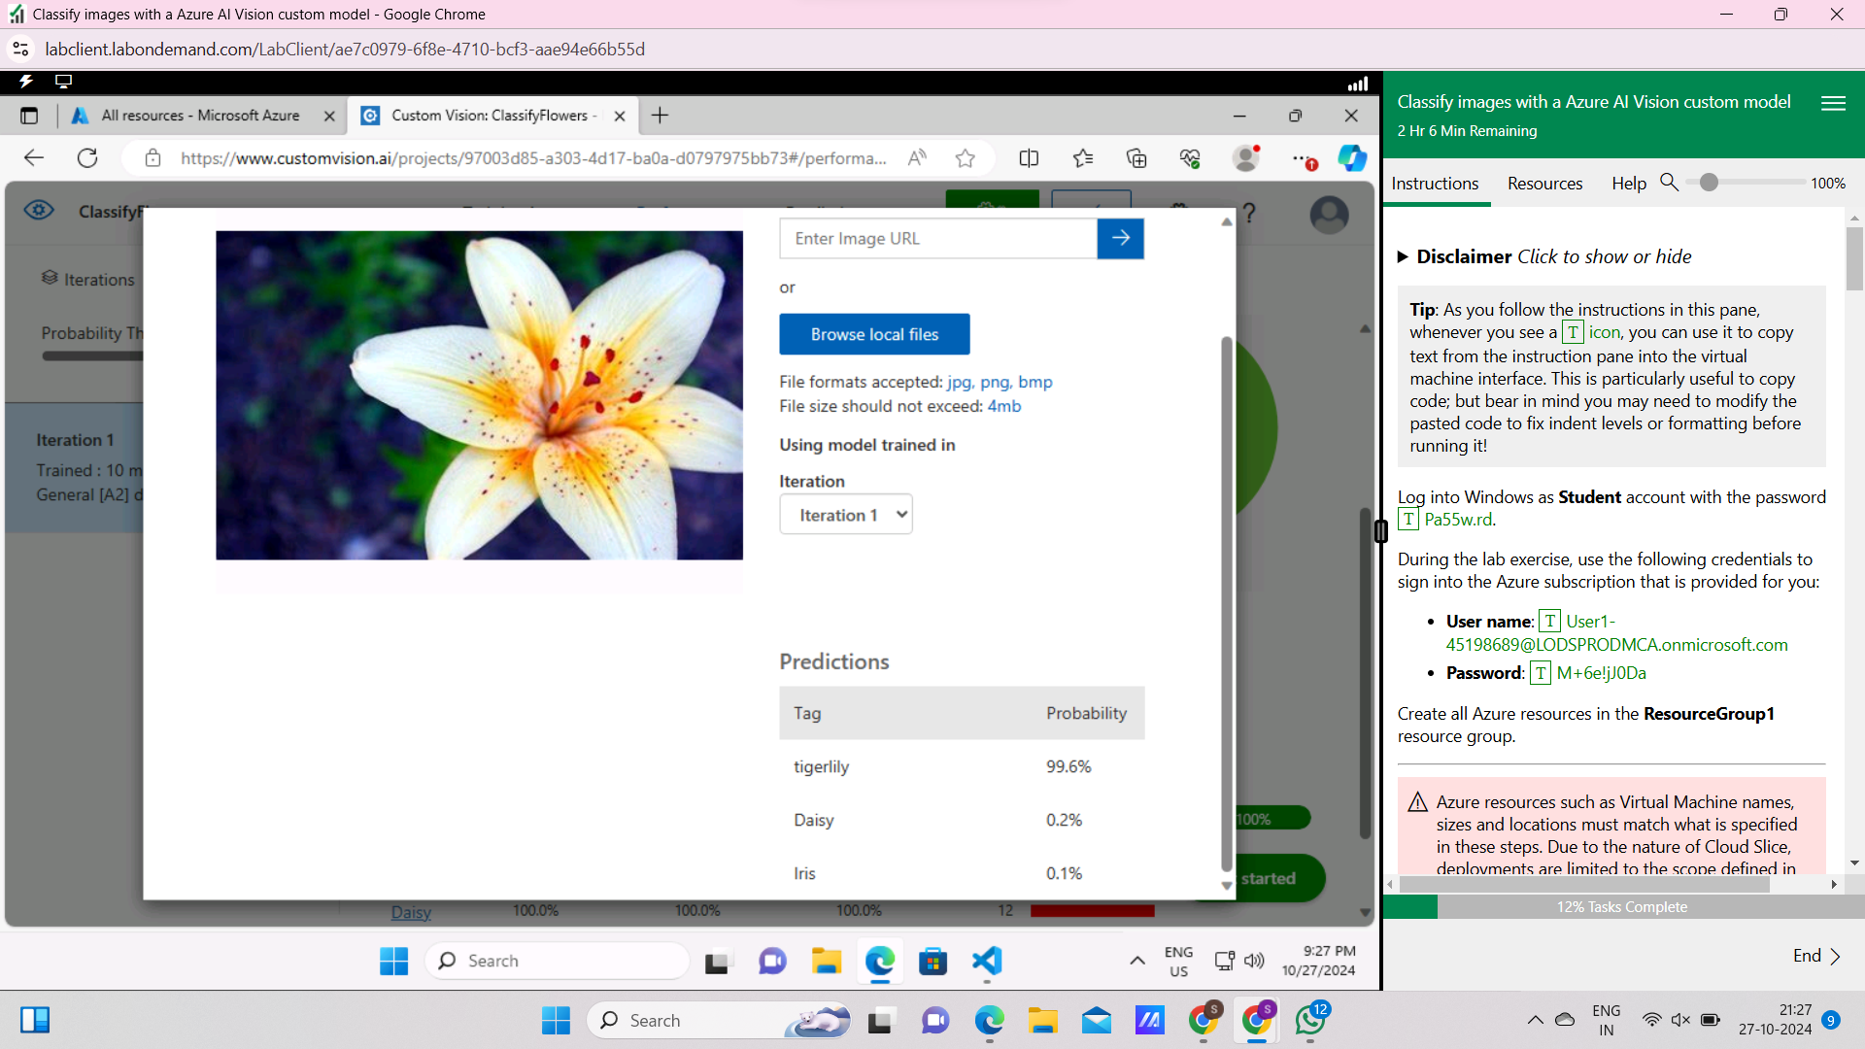

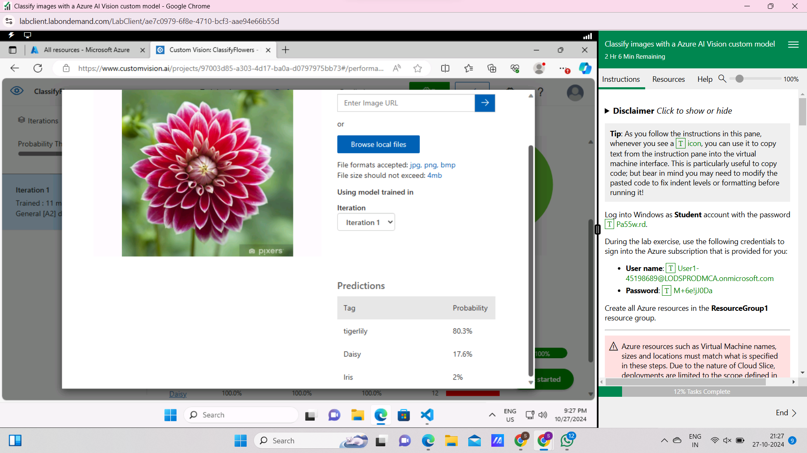

* **Deploy the model**

Once model is performing at a satisfactory level, just deploy it.

* **Publish the model**

In the Performance tab, select **Publish**.

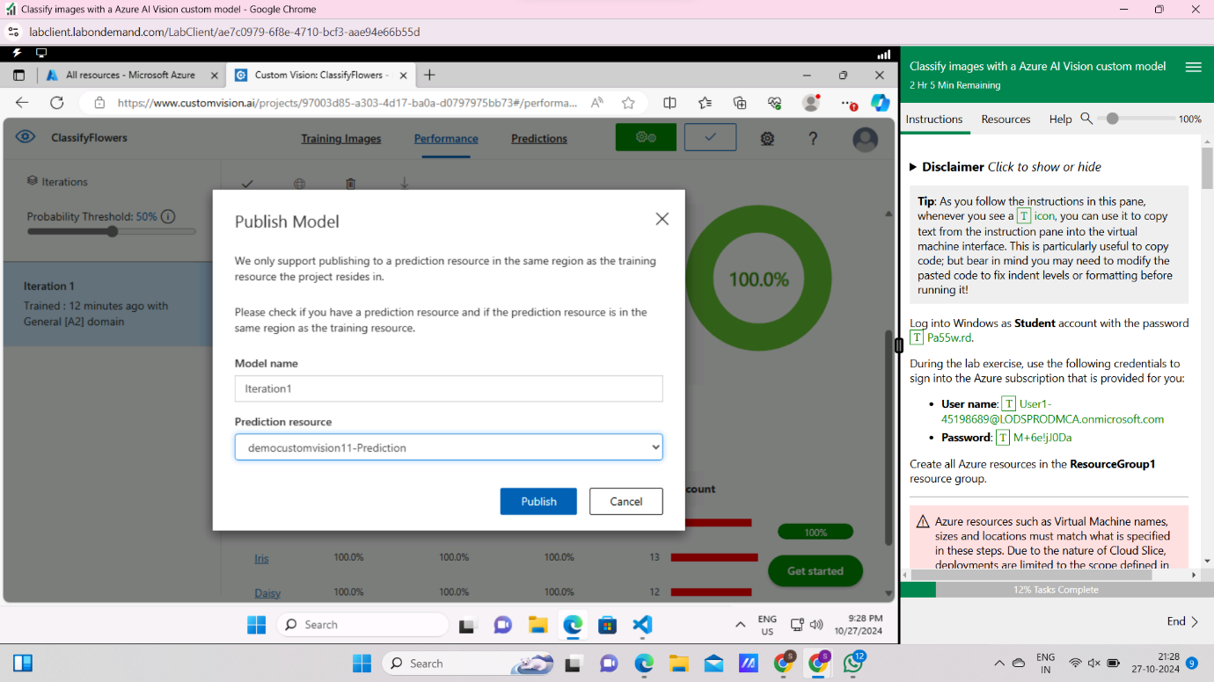

* **Test the prediction endpoint in a Python app:**

 Install the Azure Cognitive Services Custom Vision SDK for Python package with

**pip install azure-cognitiveservices-vision-customvision**

Replace <_PROJECT_ID>, <KEY> and <ENDPOINT> with the ID of project, the Key and the Endpoint of prediction resource, respectively.



    
    
    

